데이터사이언스

**Decision Tree implement assignment**

**2013011800** 구장회

**#** 순서

1. **data structure - tree class , node class**
2. **summary of algorithm for crucial method**
3. **summary of rest algorithm**
4. **instruction for compile**

**# data structure**

**[tree class]**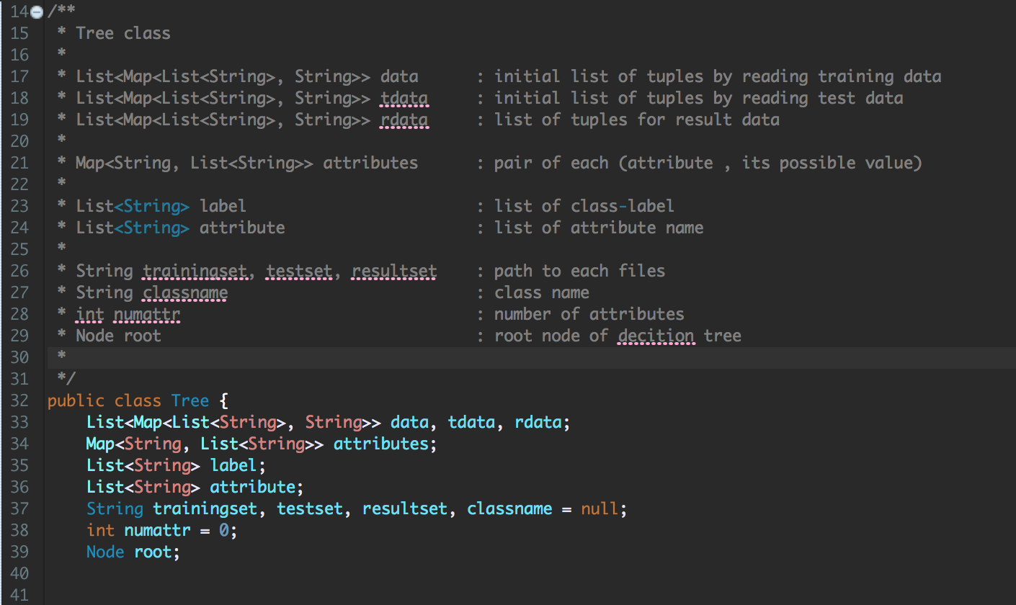

**[node class]**

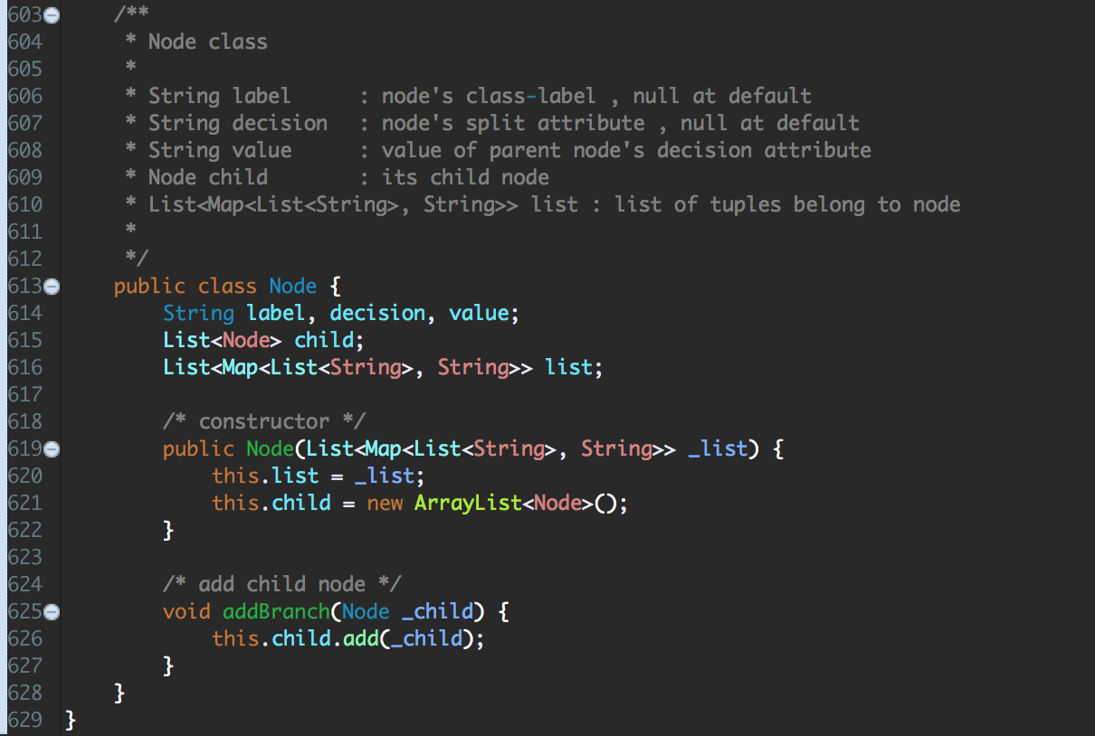

**# summary of algorithm for crucial method**

**[main method]**

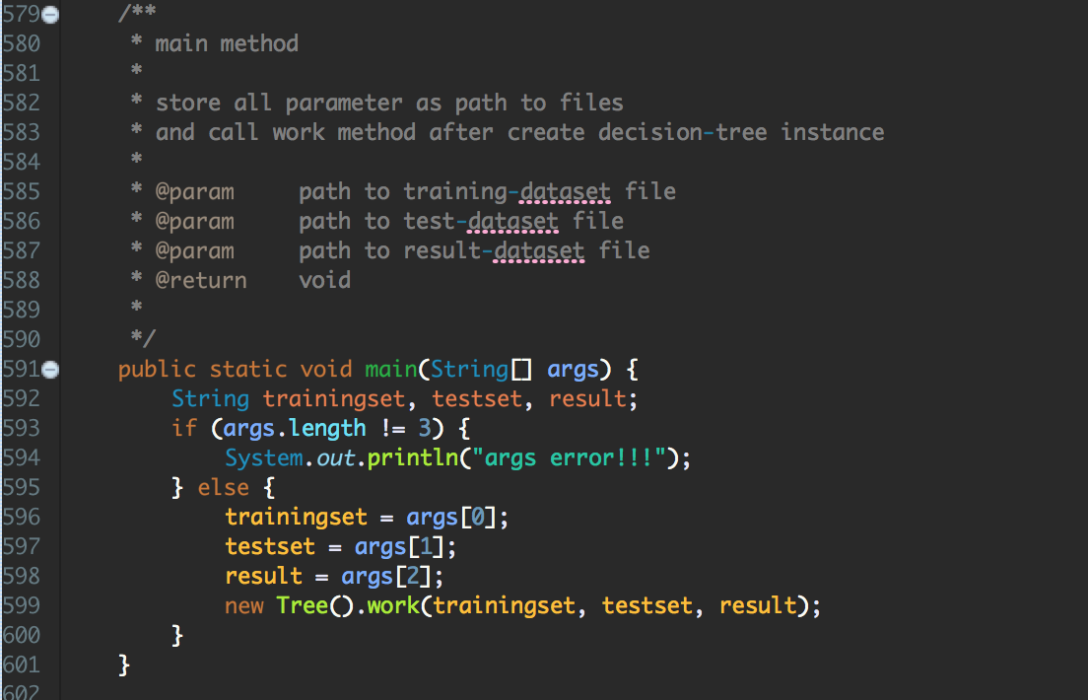

**[work() in tree class]**

* **read training data**
* **construct decision tree**
* **read test data**
* **tree test from test data**
* **write result data**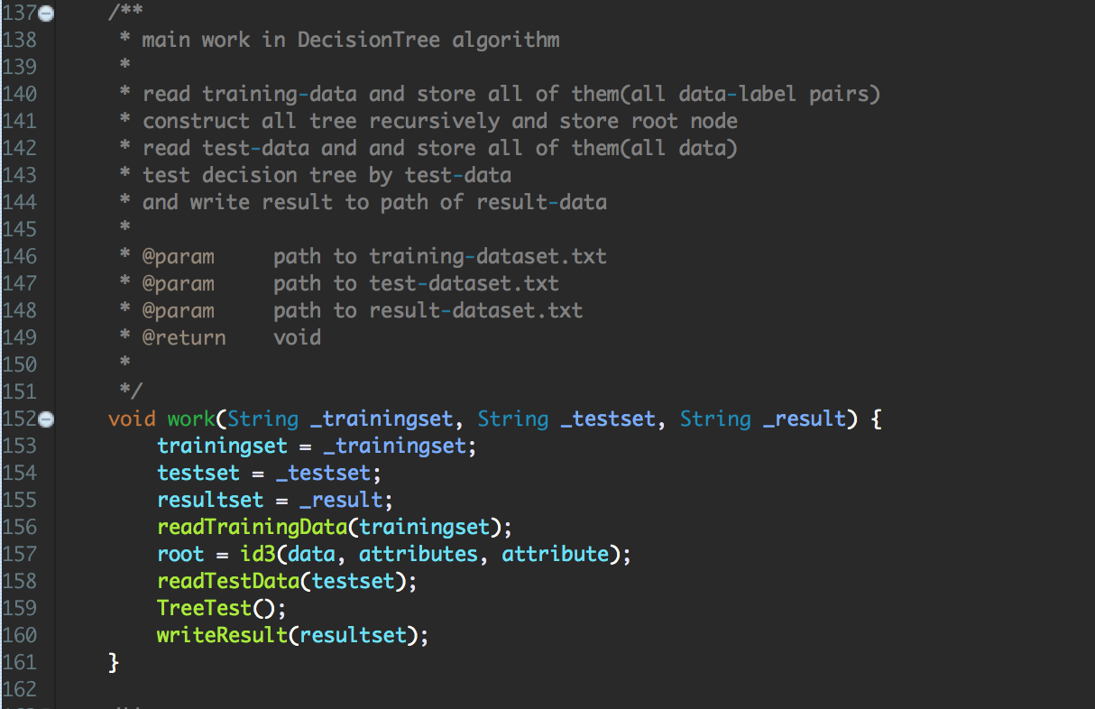

**[id3() in tree class]**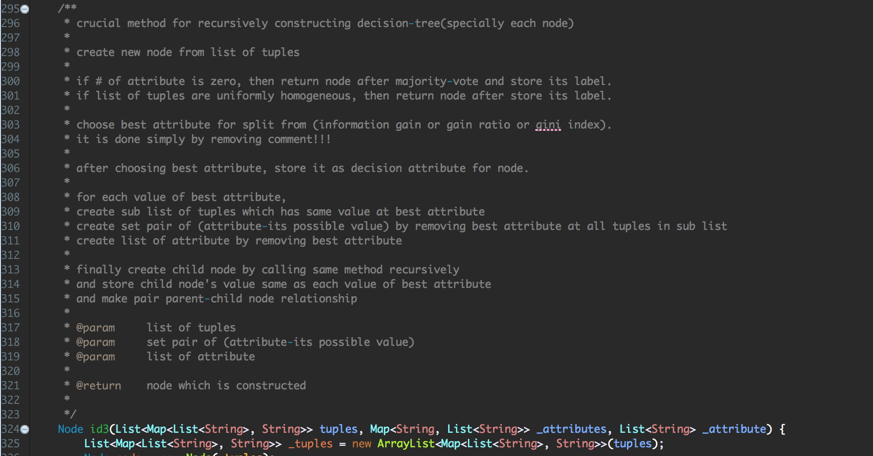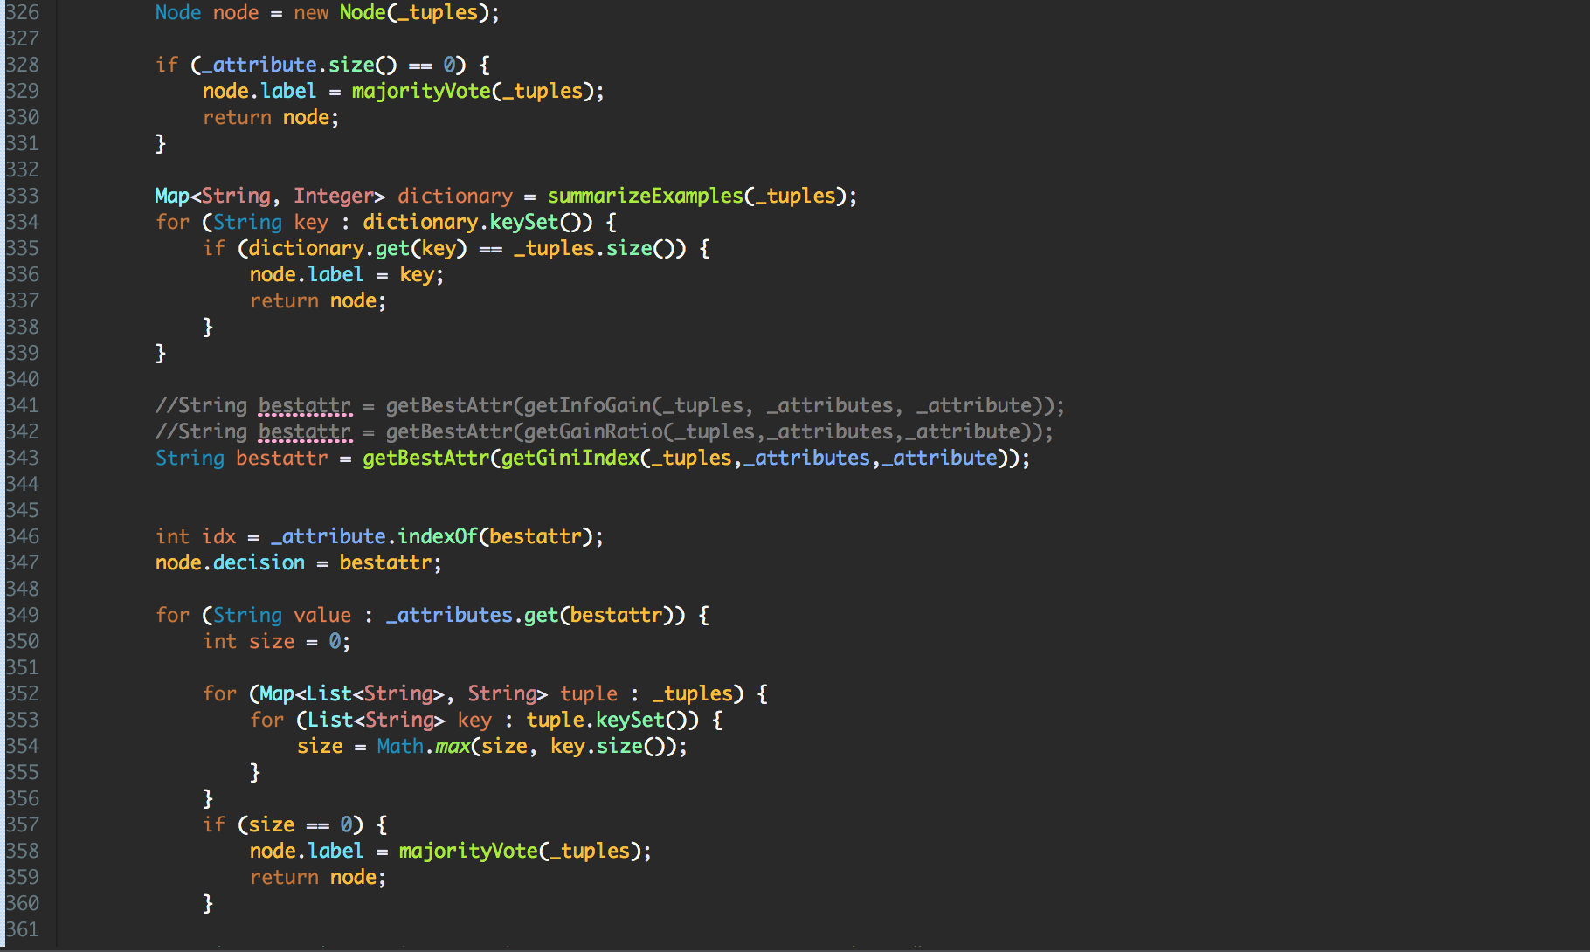

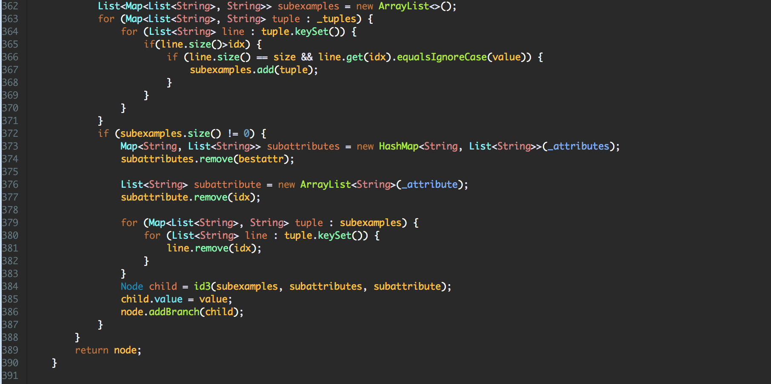

**# summary of rest algorithm**

**[readTrainingData & readTestData]**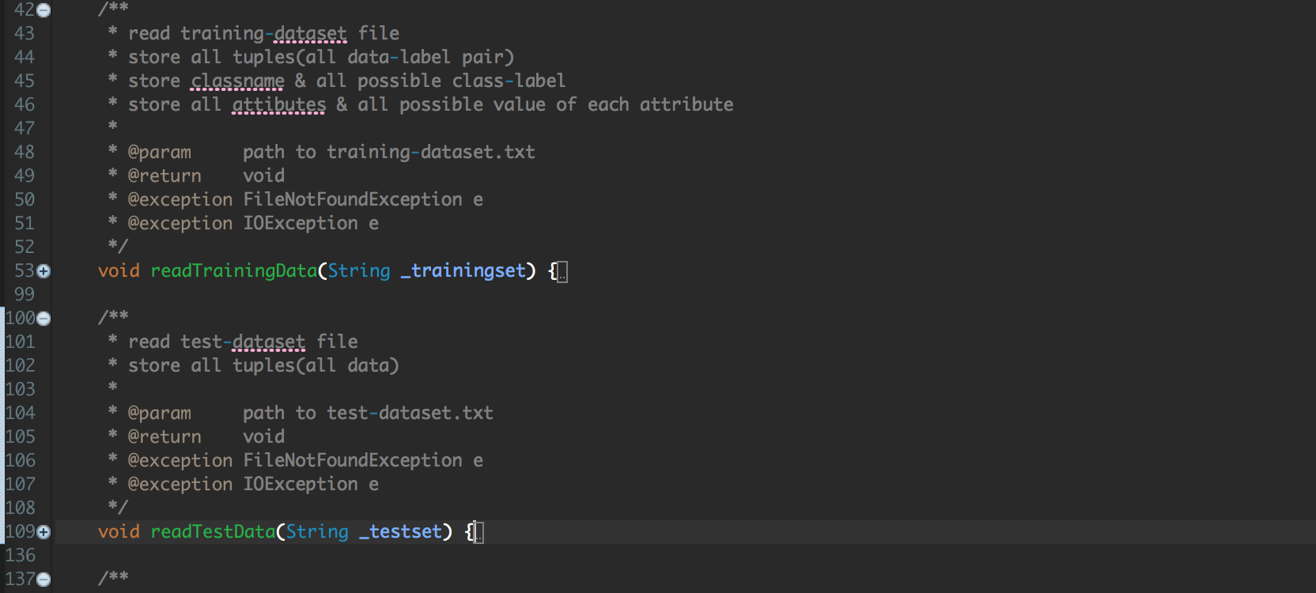

**[writeResult & TreeTest]**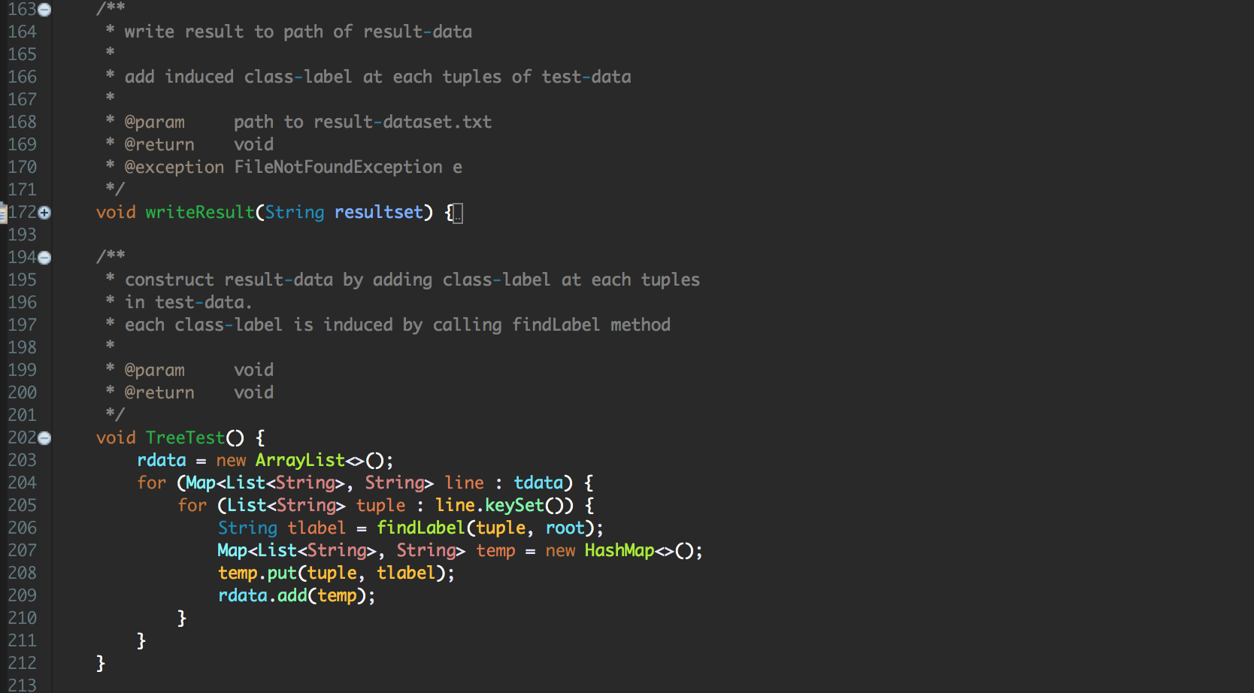

**[findLabel]**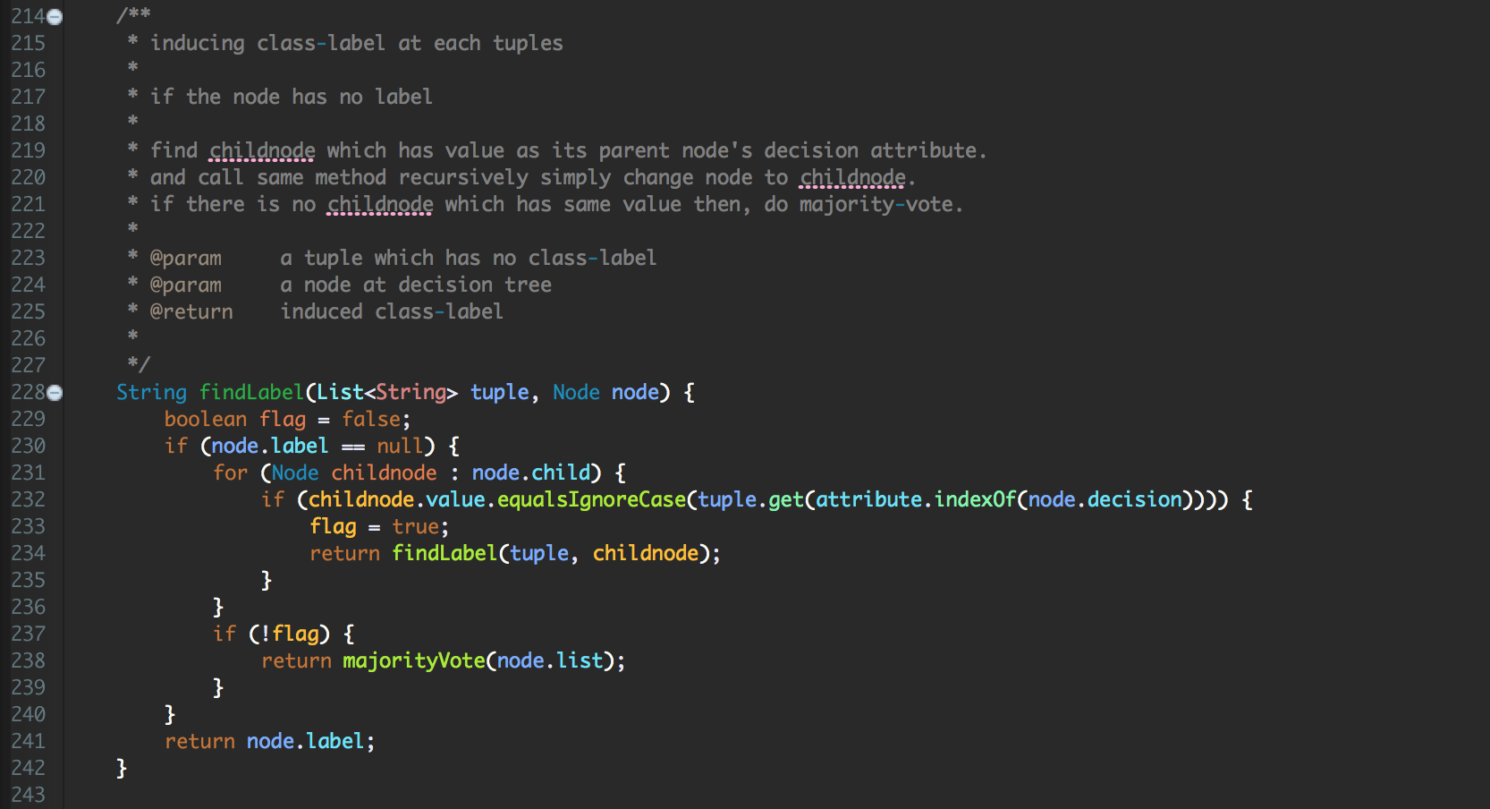

**[summarizeExamples]**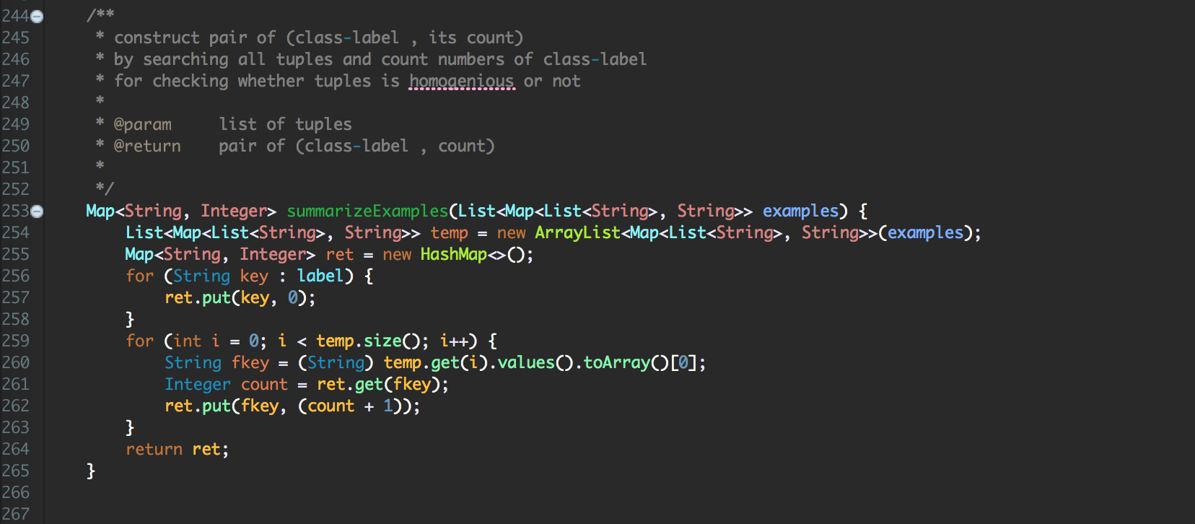

**[majority-vote]**

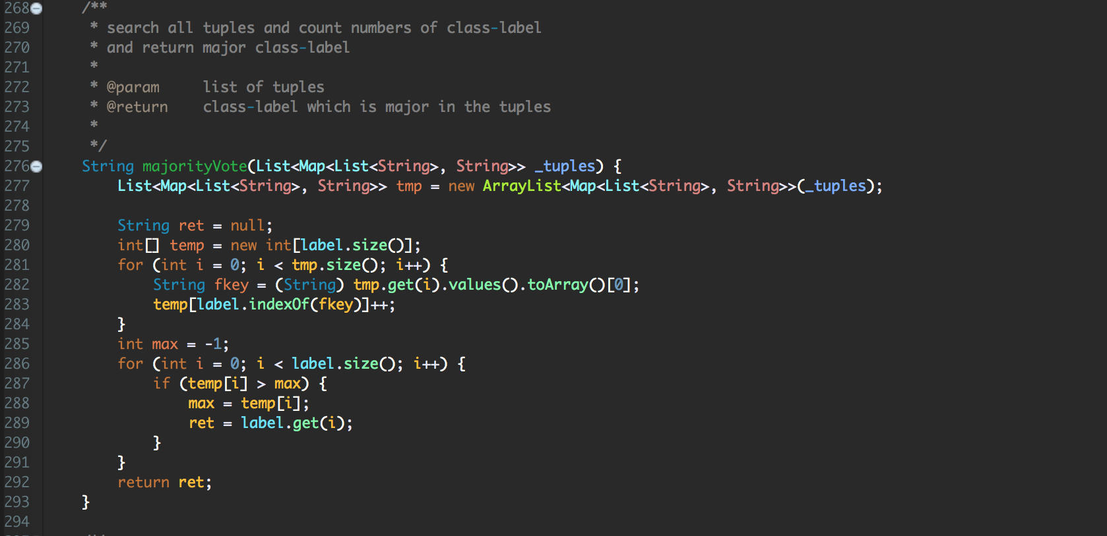

**[getBestAttr]**

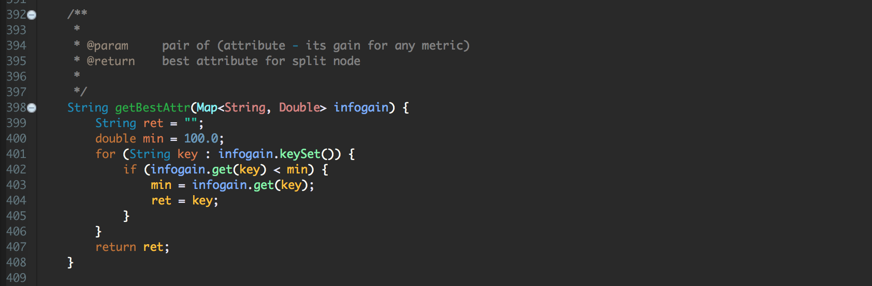

**[getGiniIndex]**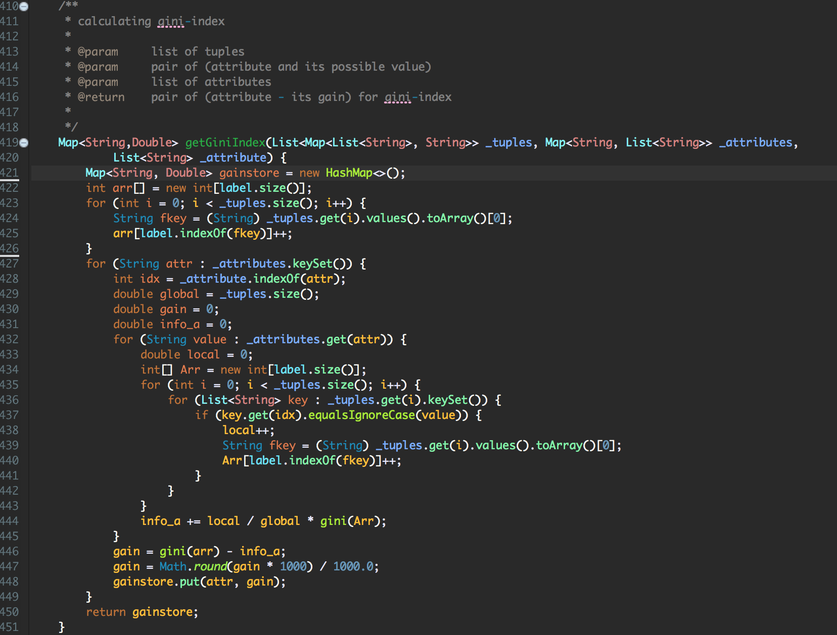

**[gini]**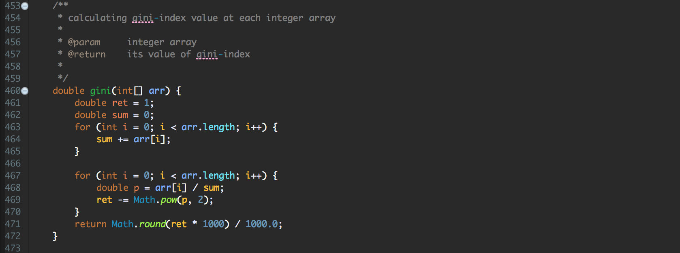

**[getGainRatio]**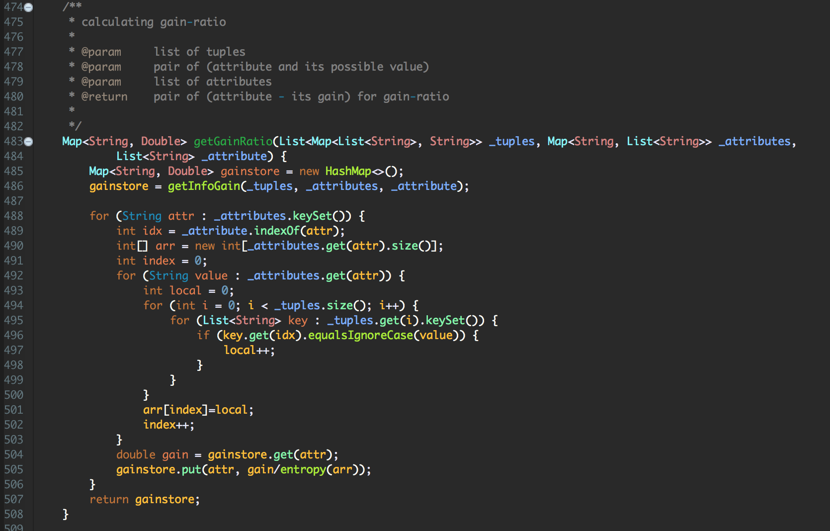

**[getInfoGain]**

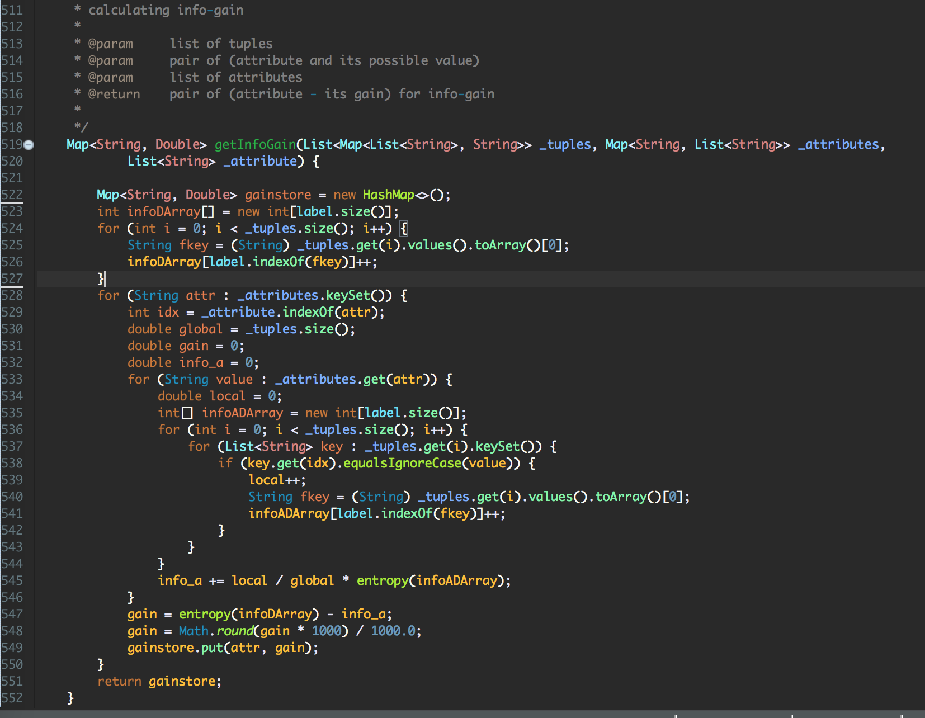

**[entropy]**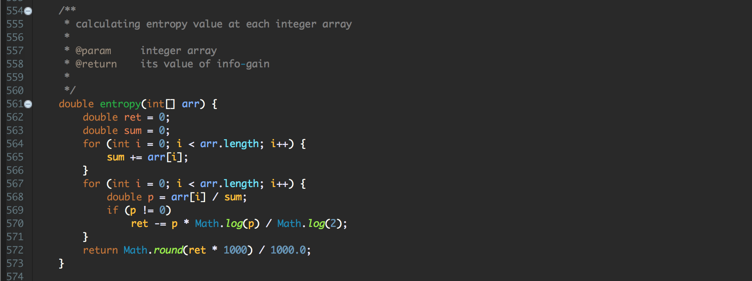

**# instruction for complile**

**[Enviorment]**

* OS : Mac OS
* Language : Java

**[Screenshot -** 실행전**]**

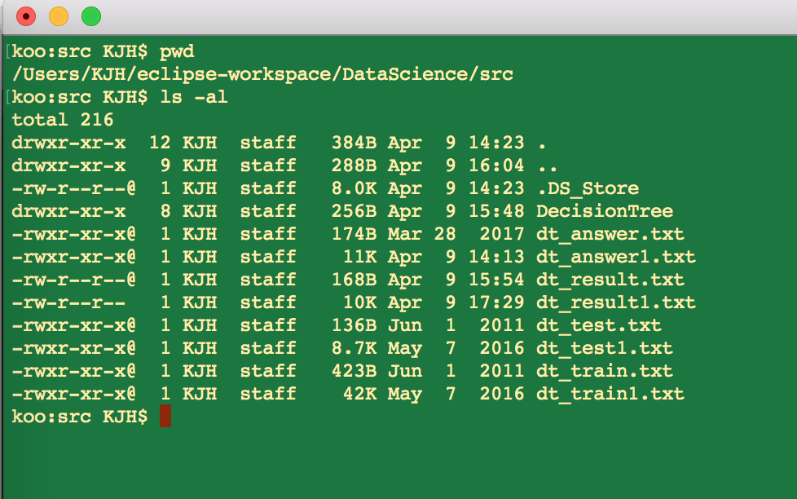

**[Screenshot -** 실행방법**]**

compile: $javac DecisionTree/Tree.java

execute : $java DecisionTree/Tree dt_train1.txt dt_test1.tst dt_result1.txt

